|  |  |  |
| --- | --- | --- |
| 1000Badge.jpg | 2024 Queensland State 1000 yard Benchrest  Championship  2-day shoot |  |

Where: International Range; Belmont Shooting Complex; Old Cleveland Road; Brisbane

When: Weekend 19-20 October 2024 @ 8:00AM

What: The International Cup - Saturday - Winner LG & HG Combined Score

The Elliott Trophy - Sunday - Winner LG & HG Combined Score

Qld State LG Champion - Combined 2 Day Score

Qld State HG Champion - Combined 2 Day Score

Medals also awarded for 2nd & 3rd place positions, Highest Single Target Score Smallest Group & Group Agg for all LG & HG

Fees: One class (LG or HG)[1] $45 (per day)

Additional class $25 (per day)

Nominations: For one or both days to [vince.vaina@gmail.com](mailto:vince.vaina@gmail.com)

Include your QRA or NRAA member number

Conditions:

* Ammunition – you will need 35 rounds per class per day.
* Ensure you have a reliable zero and know your adjustment to 1000 yards.
* Random bench draw. LG shoots first on Saturday; HG shoots first on Sunday.
* Competition will be shot on Electronic Targets – all marked.
* Bring your own wifi capable device to interface with the target display (see Fig 2).
* Competitor must be a member of the QRA, or NRAA affiliated to nominate.
* Nomination before 16 Oct 24 is essential. (Late nominations at Match Director’s discretion.)
* See additional local club shooting rules attached below.

Facilities:

* The range does not currently have toilet facilities. The nearest toilets will be found at the QRA clubhouse about 500 m away.
* Cold drinks and a BBQ lunch will be available for a small charge on both days.

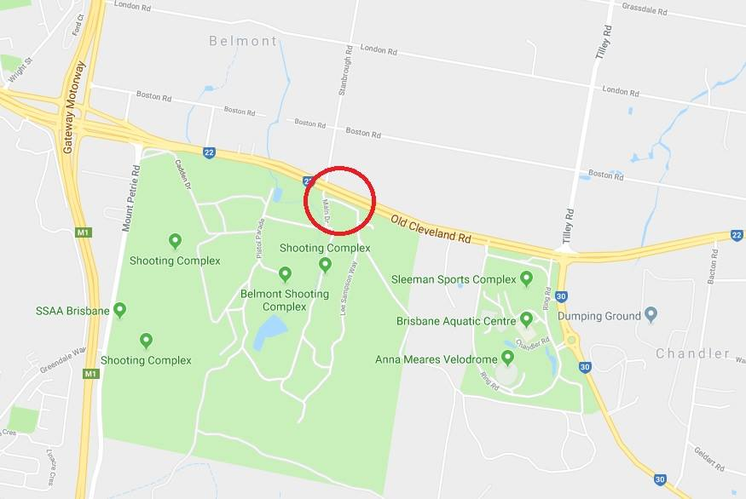

**Fig 1: Map to Range Entrance**

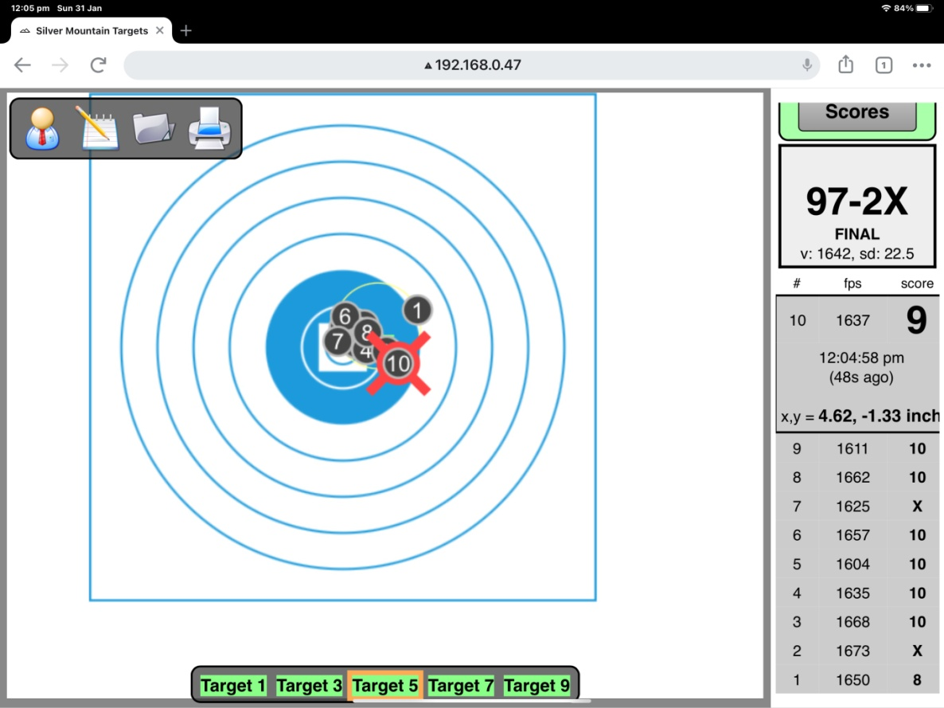

**Fig 2: Silver Mountain Target Display**

**Extract of Local Rules**

**For Brisbane 1000 yard Benchrest Club**

The conduct of **Brisbane 1000 yard Benchrest Club** shooting will comply with **NRAA Standard Shooting Rules** - with particular reference to chapters 2, 4, 5, and 22 - in so far that they apply sensibly to the conduct of 1000 yard benchrest shooting. Some NRAA SSRs are not compatible with 1000 yard benchrest shooting or the local range facilities and target system. The following **LOCAL RULES** will apply to all Brisbane 1000 yard Benchrest Club competitions.

* Rifles are NOT to be placed on firing benches before the range is declared open by the **senior RO** or the **Match Director** as applicable.
* Shooters are to seek RO assistance if they are in doubt of their rifle’s zero. Witches hats are deployed on the 300 yard mound to allow a check bore-sight of a rifle scope zero point.
* All shooters must demonstrate ability to strike within 20 inches (approx 2 MoA) of a sighter disc on the stop butt before engaging their paper target to ensure that target sensors are not struck.
* Shooters are allowed **one** sighting shot ‘on paper’ to confirm their 1000 yard zero, after the procedure above.
* No ammunition may be fired at a muzzle velocity of more than 3275 feet per second (998 metres per second) **or** at a muzzle energy of more than 3500 foot pounds (4742.5 joules).
* Shooters must supply their own ***wifi*** capable screen device - phone, tablet etc - able to receive the electronic target interface.
* Shooters must wait for the **Official Scorer** or the **RO** to examine their target before they save or clear a scored target.
* Only 5 or 10 rounds (as appropriate) may be displayed on the bench during a scoring period, with additional ammunition to be placed where the RO can easily access it. No ammunition boxes or expended cases are permitted on the bench during a scoring round – only the number of rounds needed for that string.
* If a misfire occurs during a scoring period a shooter may request the Range Officer to retrieve a replacement round from the shooter’s ammunition stock to replace the defective round and continue, provided that it is safe to do so.
* Projectiles must exceed supersonic velocity (approx 1130 fps) at 1000 yards, or the shot will fail to register on the target system.
* If a shot fails to register on the electronic target the RO is to be called to the bench immediately.  The RO in consultation with the Scorer may supply a replacement round from the shooters stock of ammunition, if both are confident that the shooter has not cross-fired or otherwise sent the shot outside the target sensor area.
* Where multiple shots (2 or more) have failed to register in a scoring string - and the targets are deemed to be working correctly - the shooter, Range Officers and Scorer will decide collectively whether it is viable for the shooter to continue the string. In most cases, no more than 4 replacement rounds will be allowed in the event of multiple shots failing to register.
* No shooter shall knowingly claim a shot he/she has not fired.
* Where a cross fire has occurred, or is suspected, a RO is to be called to the bench immediately. The RO and Scorer will confirm the cross fire using the electronic target system and cancel the cross-fired shot.
* The shooter responsible for cross-firing loses the value of that shot, which is not to be replaced.
* In the unlikely event that it is impossible to attribute the cross-fired impact, the cross-fired target gets the benefit of the higher score. However, the effected shooter must fire his/her full allocation of 5 or 10 rounds as appropriate to ensure a total score can be determined in the event of protest, or later determination of the cross-fired shot.
* The Range Officer may allow extra time in a scoring string if a shooter has been significantly held up by target fault, misfire or cross-fire.
* Where the final scores in a class (LG or HG) are tied, the winner will be the shooter with the best group aggregate in that class.
* Where the final two-gun aggregate score (LG and HG) are tied, the winner will be the shooter with the lower sum total of LG and HG group aggregate; i.e. the shooter’s LG group aggregate and HG group aggregate will be added together, with the lowest sum deciding the winner.
* No non-shooter, other than the Range Officers, may be forward of the yellow line during a scoring period.

--------------- ~ ---------------

1. Light Gun maximum weight 17lb (7.71kg) – Heavy Gun no limit